How to create variable for file name and folder name in the copy activity

1. As previously created create datasets using parameters and create linked service
2. Now do the same copy activity as previously done
3. Now create one more get data activity by going to general-> set variable
4. 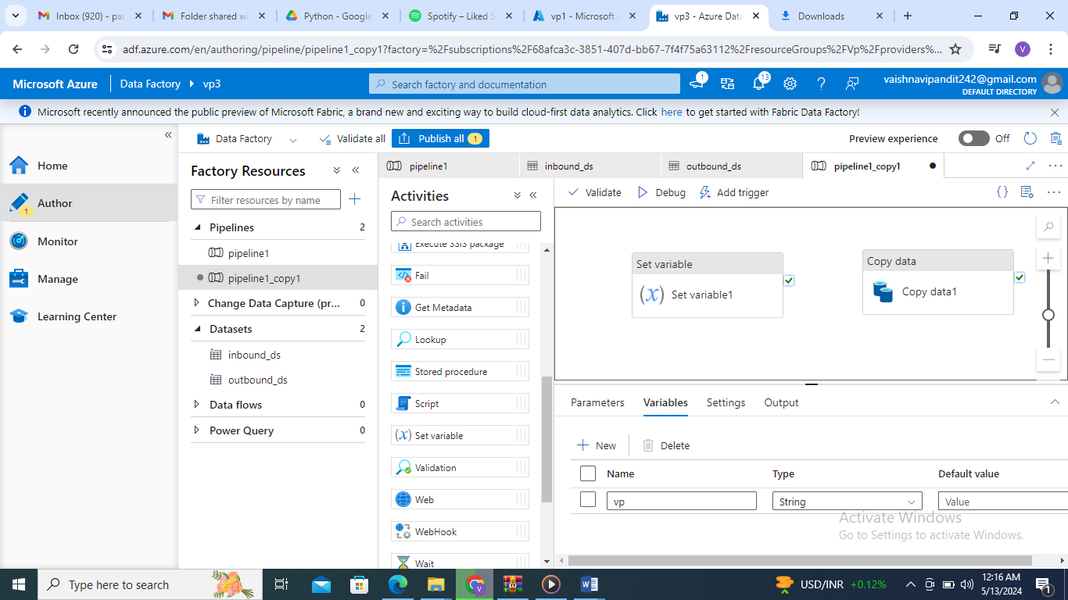
5. Add variable
6. Now go to settings

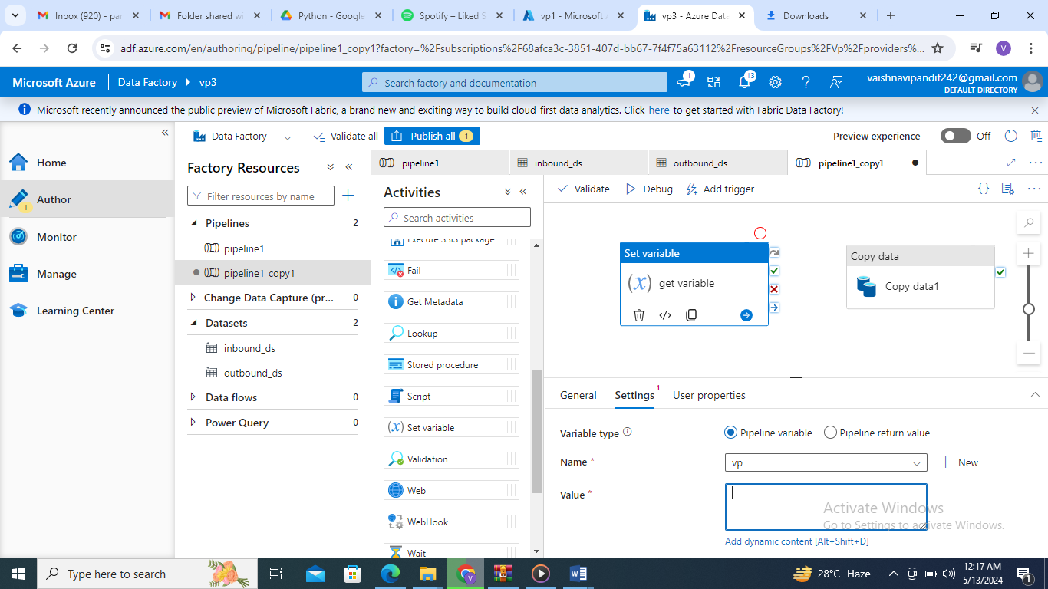

1. Add the value using add dynamic

And add value as folder name

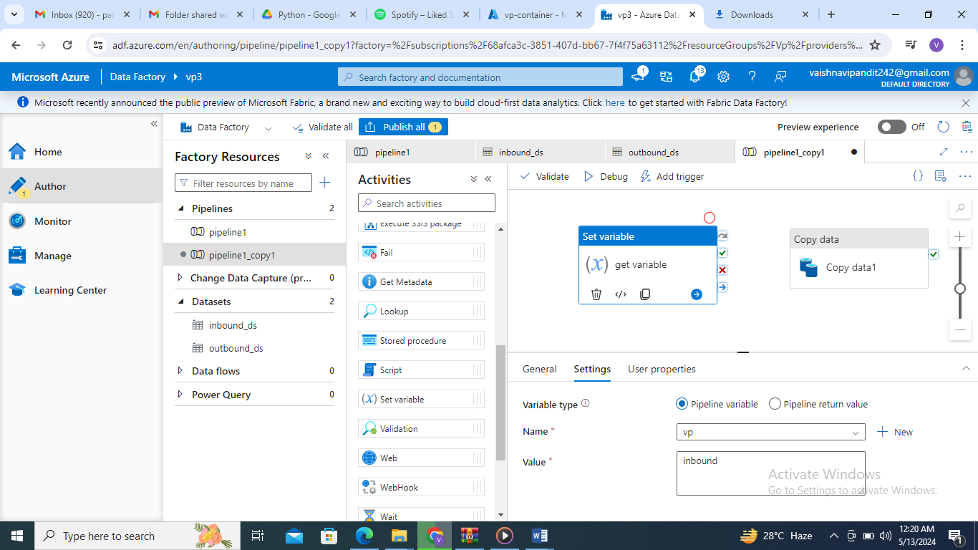

1. Now go to copy activity

In source value ->add dynamic content->variable->add this variable

And now publish and debug the activity